Prepare Multiple Nodes on Alibaba Cloud

1.1. Purchase Single Node on Alibaba Cloud
Step 1: Click https://homenew.console.aliyun.com/home/dashboard/ProductAndService, choose the ECS service,
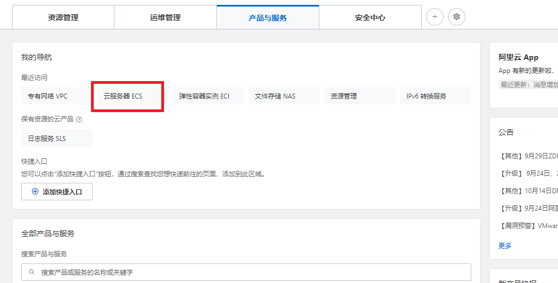
Step 2: Create a new instance, choose pay as you go, choose ecs.c7.2xlarge, choose Ubuntu 16.04 64 bits, choose ESSD, choose no IPv4 address, choose your password Y0urpassword,
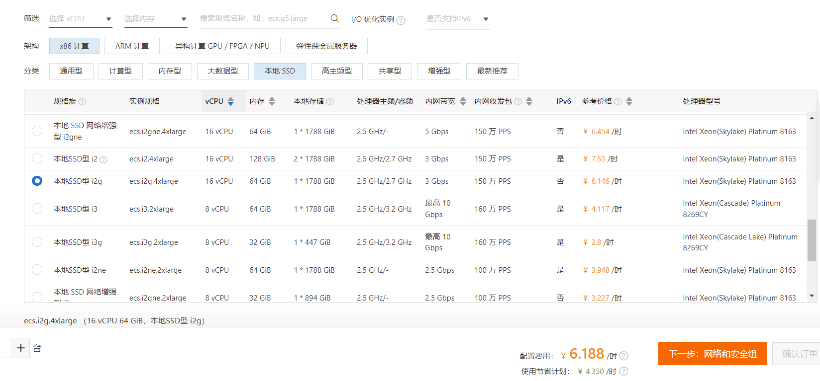
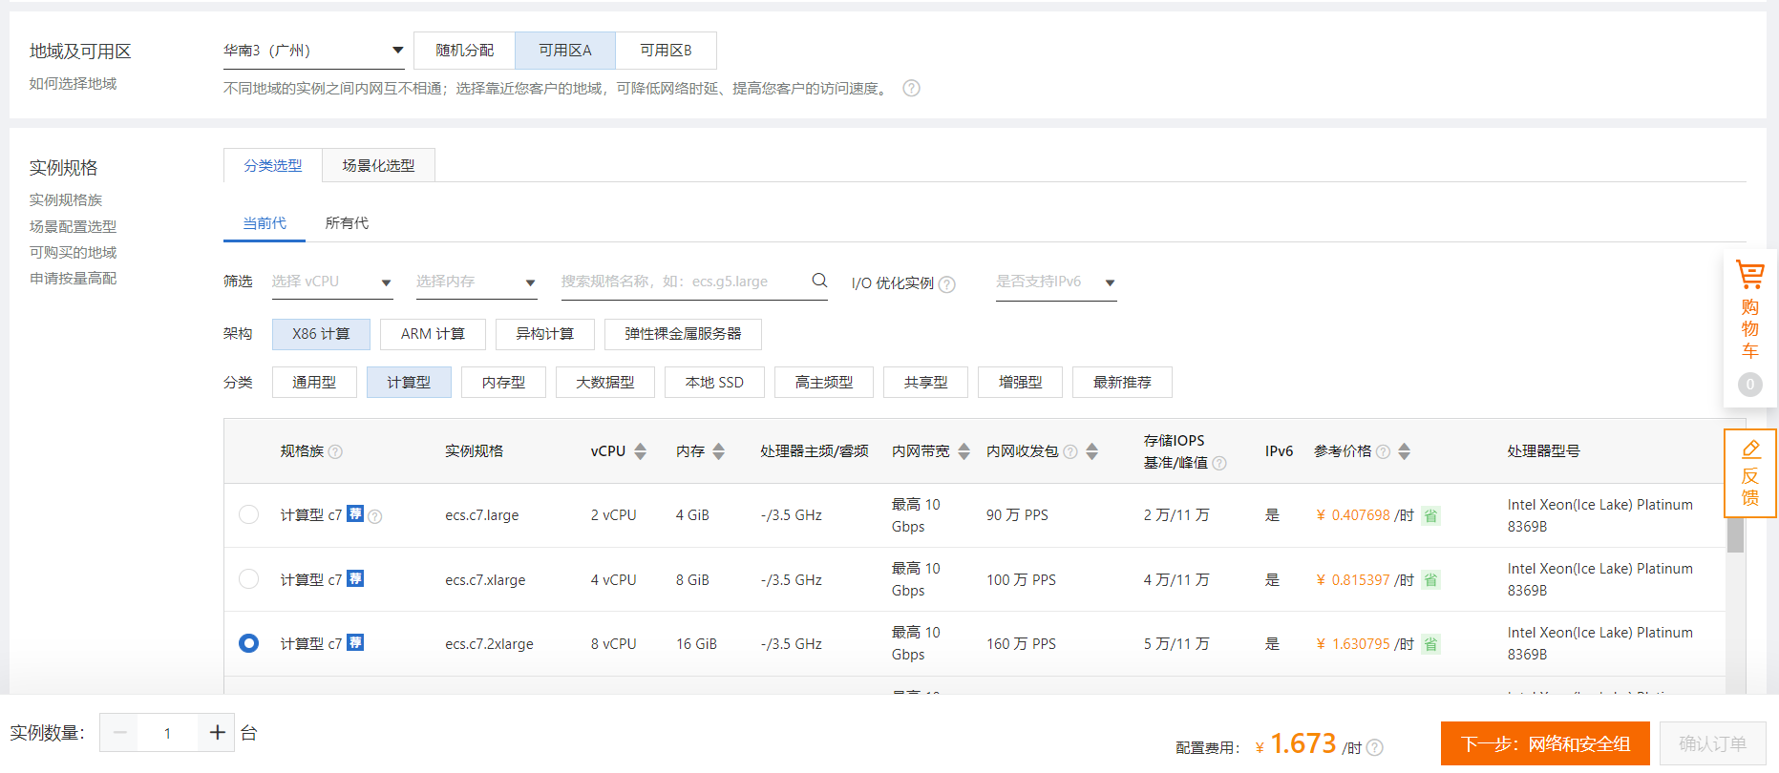
Step 3: Double-check the order,
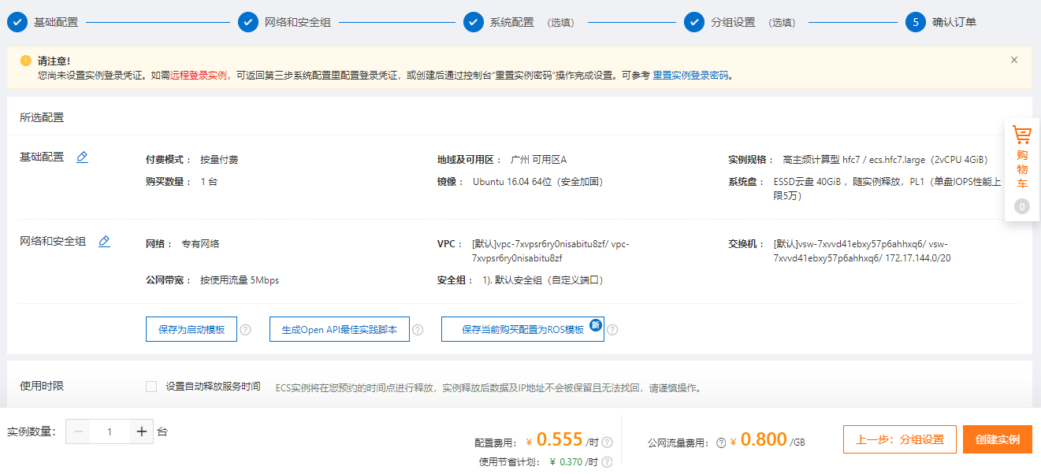

Step 4: Pay the order,
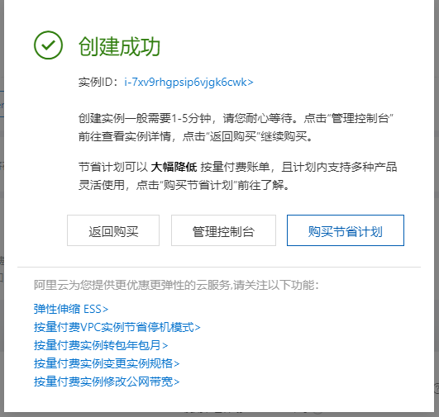
Step 5: Access the ECS instance via Alibaba Workbench, where the default username is root,
So far, the ECS instance cannot access the Internet because it has no IP address.

1.2. Purchase a NAT Gateway

Step 1: Click https://vpc.console.aliyun.com/nat/cn-guangzhou/nats, purchase 2 public IP addresses, create a NAT gateway,
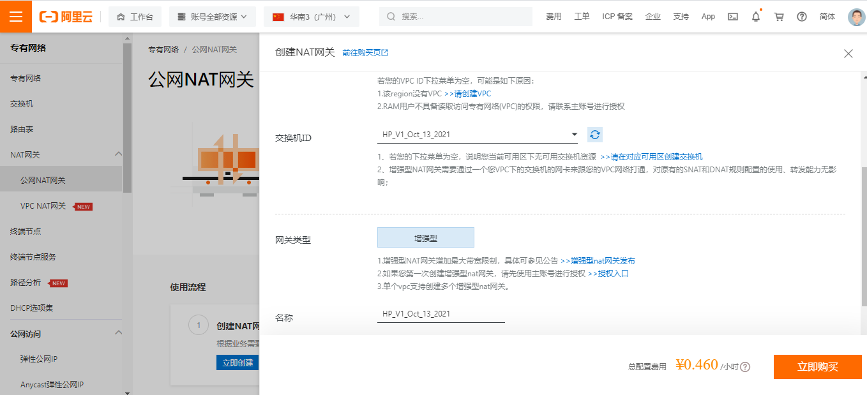
Step 2: After purchasing 2 public IP addresses, we have 8.163.56.8 and 8.138.164.210,
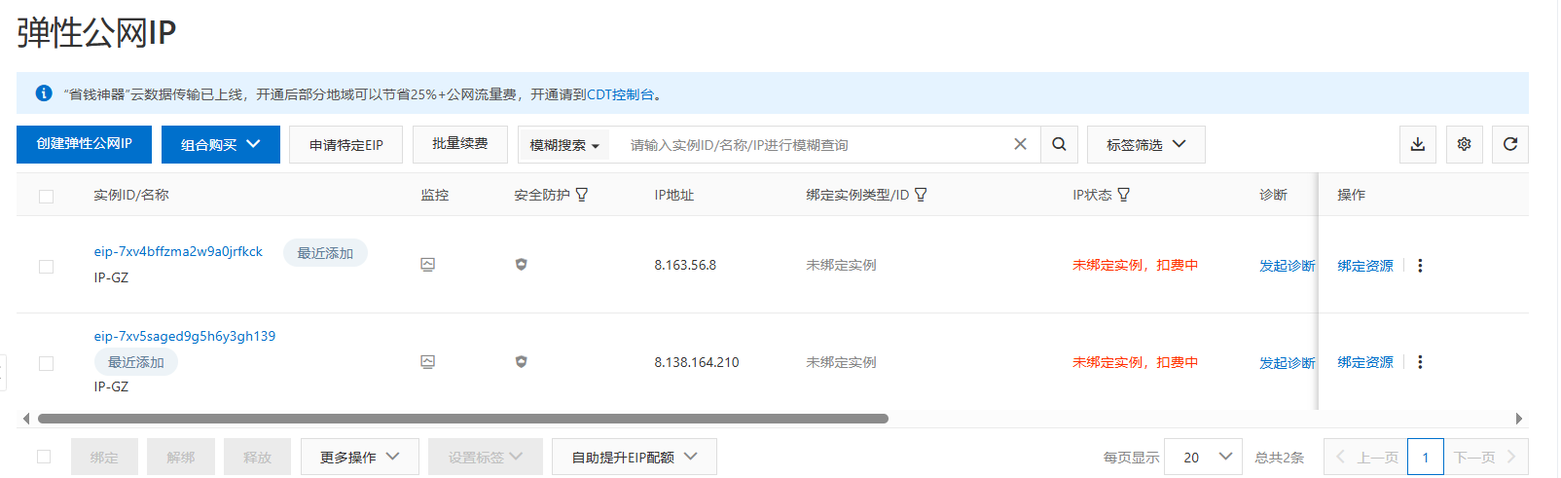

1.3. Purchase Multiple Node on Alibaba Cloud
Step 1: Click https://vpc.console.aliyun.com/vpc/cn-guangzhou/vpcs, purchase another 10 ECS nodes,
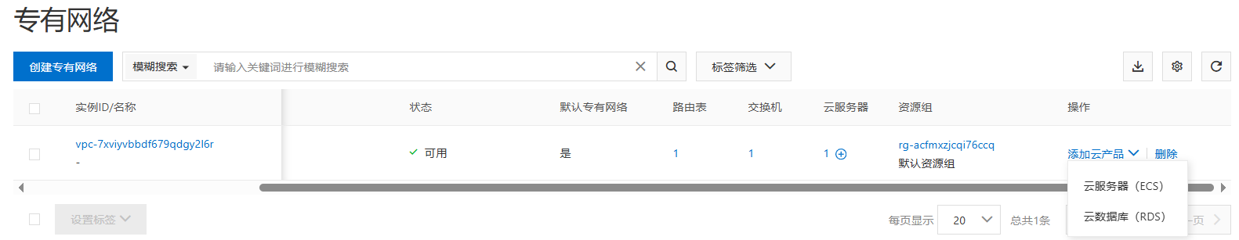
choose pay as you go, choose ecs.c7.2xlarge, choose Ubuntu 16.04 64 bits, choose ESSD, choose no IPv4 address, choose your password Y0urpassword,
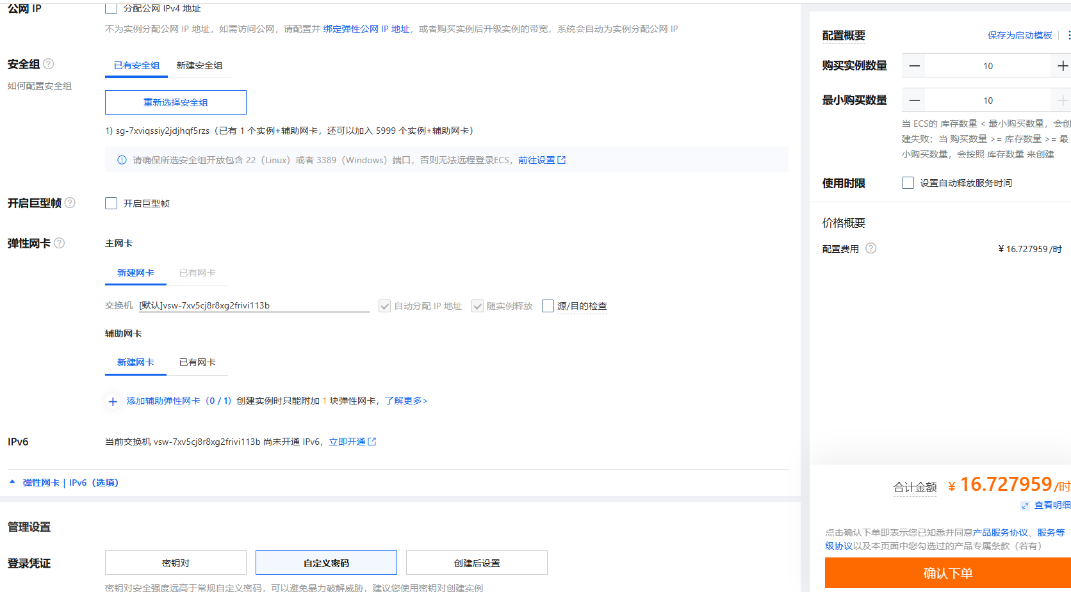

1.4. Configure the NAT Gateway
Step 1: Click https://vpc.console.aliyun.com/nat/cn-guangzhou/nats, configure the NAT gateway, where the IP address 8.163.56.8 for DNAT and 8.138.164.210 for SNAT (DNAT for Internet users and SNAT for VM inside). Currently, we have 1 NAT, 2 Public IP addresses, and 11 ECS, our target is as follows:
For NAT (Public IP):
SNAT | DNAT
8.138.164.210 | 8.163.56.8

For ECS maps (Inside IP):
SNAT | DNAT
- | 172.31.210.67
 | 172.31.210.70
 | 172.31.210.71
 | 172.31.210.72
 | 172.31.210.73
 | 172.31.210.74
 | 172.31.210.75
 | 172.31.210.76
 | 172.31.210.77
 | 172.31.210.78
 | 172.31.210.79

Step 2: Configure the SNAT,
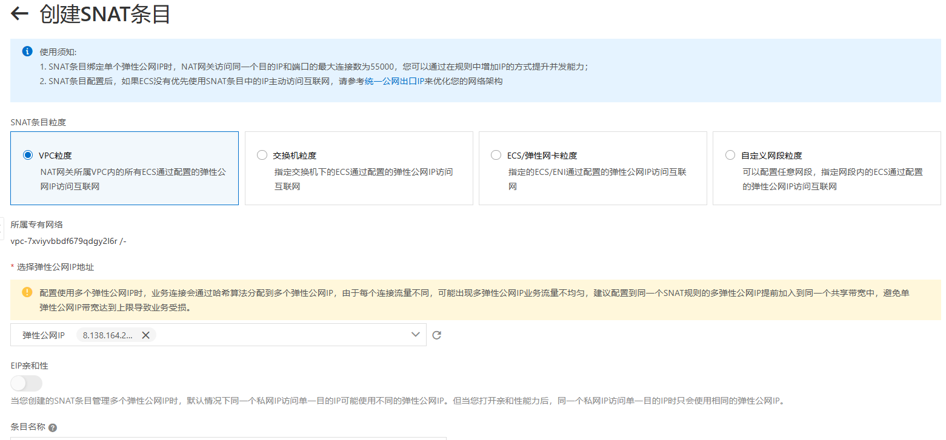

Step 3: Configure the DNAT,
ECS maps:
DNAT Public IP and Port Number | DNAT Inside IP
8.163.56.8:9999 | 172.31.210.67
8.163.56.8:10000 | 172.31.210.70
8.163.56.8:10001 | 172.31.210.71
8.163.56.8:10002 | 172.31.210.72
8.163.56.8:10003 | 172.31.210.73
8.163.56.8:10004 | 172.31.210.74
8.163.56.8:10005 | 172.31.210.75
8.163.56.8:10006 | 172.31.210.76
8.163.56.8:10007 | 172.31.210.77
8.163.56.8:10008 | 172.31.210.78
8.163.56.8:10009 | 172.31.210.79

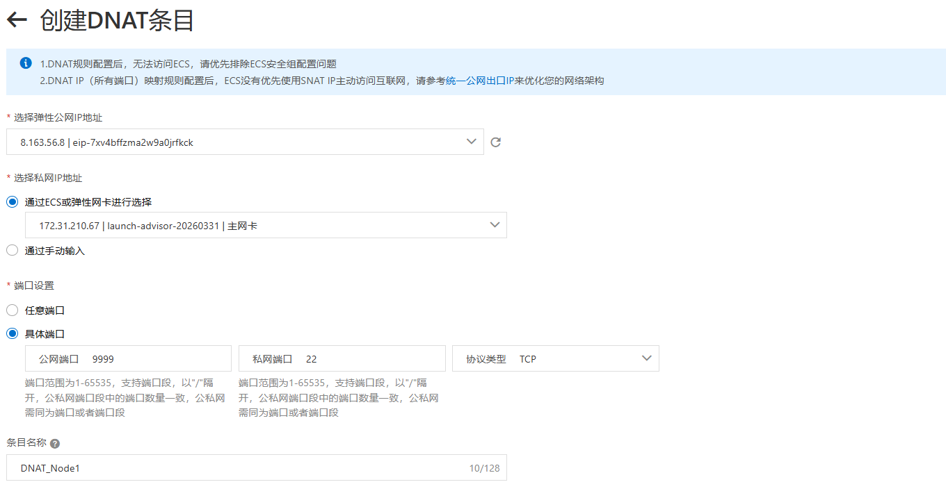
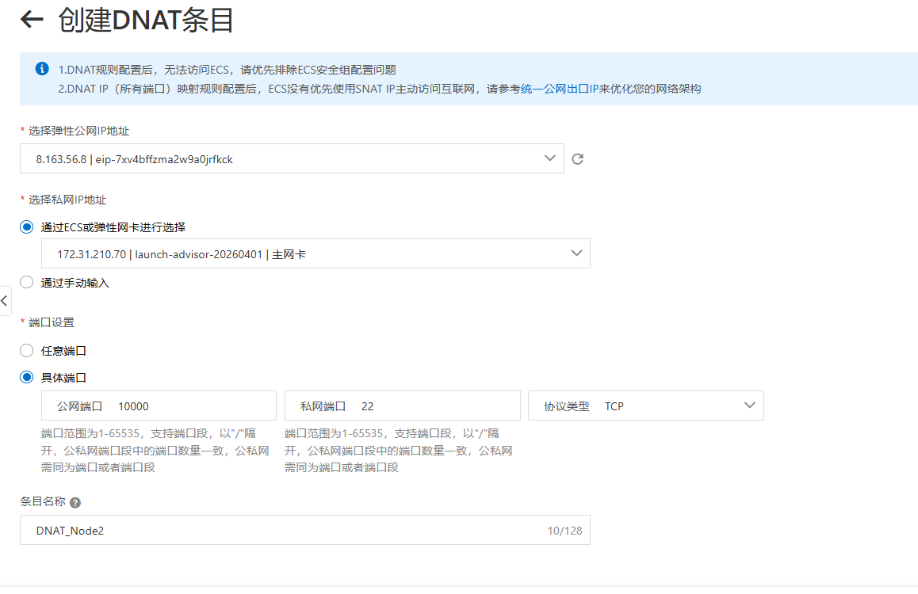
Access the inside IPs via Xshell,
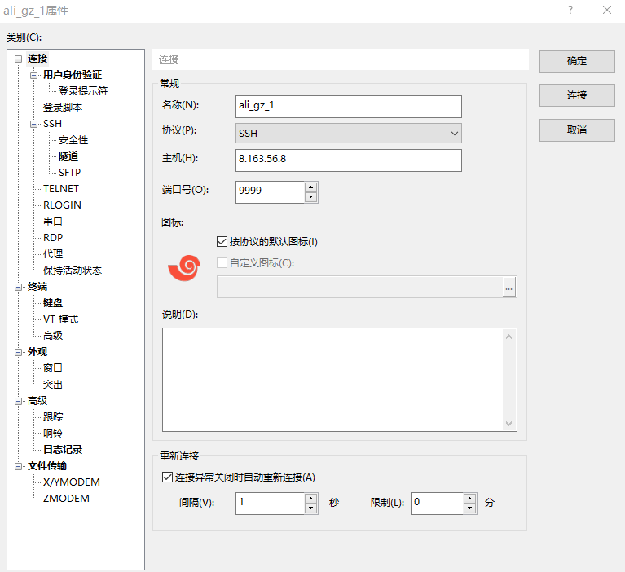
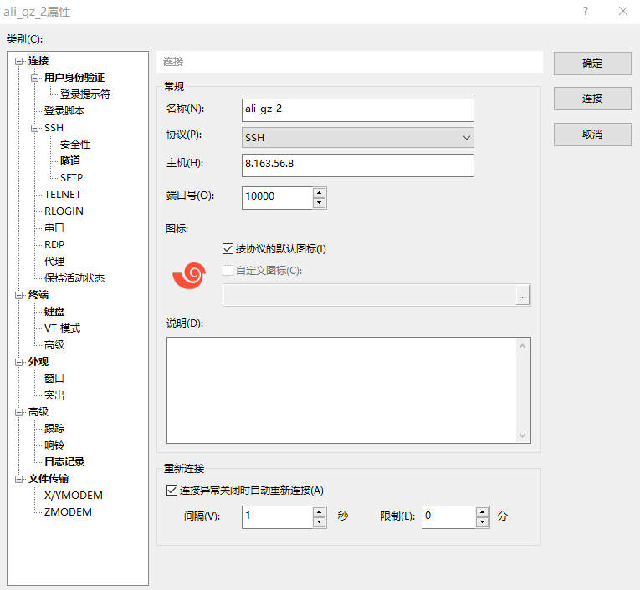

1.5. Configure the password-free SSH
Step 1: The target is as follows,
Host with free-password SSH to
172.31.210.67
172.31.210.70
172.31.210.71
172.31.210.72
172.31.210.73
172.31.210.74
172.31.210.75
172.31.210.76
172.31.210.77
172.31.210.78
172.31.210.79

Step 2: Configure the 172.31.210.67,
$ ssh-keygen

$ ssh root@172.31.210.70 'mkdir -p .ssh && cat > .ssh/authorized_keys' < ~/.ssh/id_rsa.pub
$ ssh root@172.31.210.71 'mkdir -p .ssh && cat > .ssh/authorized_keys' < ~/.ssh/id_rsa.pub
$ ssh root@172.31.210.72 'mkdir -p .ssh && cat > .ssh/authorized_keys' < ~/.ssh/id_rsa.pub
$ ssh root@172.31.210.73 'mkdir -p .ssh && cat > .ssh/authorized_keys' < ~/.ssh/id_rsa.pub
$ ssh root@172.31.210.74 'mkdir -p .ssh && cat > .ssh/authorized_keys' < ~/.ssh/id_rsa.pub
$ ssh root@172.31.210.75 'mkdir -p .ssh && cat > .ssh/authorized_keys' < ~/.ssh/id_rsa.pub
$ ssh root@172.31.210.76 'mkdir -p .ssh && cat > .ssh/authorized_keys' < ~/.ssh/id_rsa.pub
$ ssh root@172.31.210.77 'mkdir -p .ssh && cat > .ssh/authorized_keys' < ~/.ssh/id_rsa.pub
$ ssh root@172.31.210.78 'mkdir -p .ssh && cat > .ssh/authorized_keys' < ~/.ssh/id_rsa.pub
$ ssh root@172.31.210.79 'mkdir -p .ssh && cat > .ssh/authorized_keys' < ~/.ssh/id_rsa.pub

$ ssh 172.31.210.70 "echo 'hi'"
$ ssh 172.31.210.71 "echo 'hi'"
$ ssh 172.31.210.72 "echo 'hi'"
$ ssh 172.31.210.73 "echo 'hi'"
$ ssh 172.31.210.74 "echo 'hi'"
$ ssh 172.31.210.75 "echo 'hi'"
$ ssh 172.31.210.76 "echo 'hi'"
$ ssh 172.31.210.77 "echo 'hi'"
$ ssh 172.31.210.78 "echo 'hi'"
$ ssh 172.31.210.79 "echo 'hi'"

1.6. Free the NAT Gateway
Step 1: Click https://vpc.console.aliyun.com/nat/cn-guangzhou/nats/ngw-7xv0l1e59yh41ve2vhc0g/snats, delete SNAT,
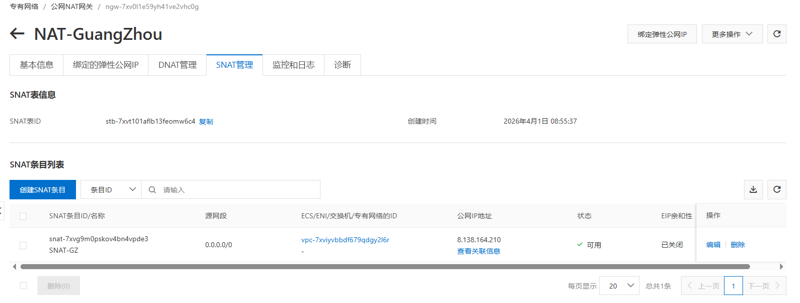
Step 2: Click https://vpc.console.aliyun.com/nat/cn-guangzhou/nats, unbind public IP, free public IP,
Step 3: Click https://homenew.console.aliyun.com/home/dashboard/ProductAndService, delete ECS,
Step 4: Click https://vpc.console.aliyun.com/nat/cn-guangzhou/nats, delete NAT

Prepare Fabric Multiple Nodes

2.1. Configure Multiple Nodes
Step 1: Configure the host names
# sudo vi /etc/hosts
:set paste
i

172.31.210.67 peer0.org1.example.com

172.31.210.70 client1.peer
172.31.210.71 client2.peer
172.31.210.72 client3.peer
172.31.210.73 client4.peer
172.31.210.74 client5.peer
172.31.210.75 client6.peer
172.31.210.76 client7.peer

172.31.210.77 order.example.com
172.31.210.78 order2.example.com
172.31.210.79 order3.example.com

2.2. Install Dependencies
Step 1: Install the prerequisites for each node
// Prerequisite: Git
$ sudo apt-get update
$ sudo apt purge -y git
$ sudo apt-get install -y git // =1:2.7.4-0ubuntu1.9
$ git version // 2.7.4
$ export PATH=$PATH:/usr/lib/git-core
$ echo 'export PATH=$PATH:/usr/lib/git-core' >> ~/.bashrc
$ source ~/.bashrc

Step 2: Install the cURL
// Prerequisite: cURL
$ sudo apt-get install -y curl
$ curl –version // 7.47.0

Step 3: Install the wget
// Prerequisite: wget
$ sudo apt-get install -y wget=1.17.1-1ubuntu1.5

Step 4: Install the docker
// Prerequisite: Docker 17.06.2-ce or greater: Docker 17.12.0-ce
$ sudo apt-get purge -y docker-ce docker-ce-cli
$ wget https://download.docker.com/linux/ubuntu/gpg
$ sudo apt-key add gpg
$ echo 'deb [arch=amd64] https://download.docker.com/linux/ubuntu xenial stable' | sudo tee /etc/apt/sources.list.d/docker.list
$ sudo apt-get update
$ apt-cache madison docker-ce
$ sudo apt-get install docker-ce=17.12.0~ce-0~ubuntu
$ sudo usermod -aG docker $USER
$ docker version

Step 5 (Condition: Outside the Great Wall): Install the docker-compose
// Prerequisite: Docker Compose 1.14.0 or greater: 1.21.0
$ sudo apt-get purge -y docker-compose
$ sudo curl -L https://github.com/docker/compose/releases/download/1.21.0/docker-compose-`uname -s`-`uname -m` -o /usr/local/bin/docker-compose
$ sudo chmod +x /usr/local/bin/docker-compose
$ docker-compose version

Step 5 (Condition: Within the Great Wall): Install the docker-compose
// Prerequisite: Docker Compose 1.14.0 or greater: 1.21.0
$ sudo apt-get purge -y docker-compose
$ mkdir downloads
$ cd $HOME/downloads
$ wget https://gitee.com/joe32065/fabric_2_2/releases/download/fabric-v2.2.0/docker-compose
$ sudo chmod +x docker-compose
$ sudo mv docker-compose /usr/local/bin
$ docker-compose version

Step 6 (Condition: Outside the Great Wall): Install the Golang,
// Prerequisite: Go v1.14.8
$ cd $HOME/downloads
$ wget https://golang.org/dl/go1.14.8.linux-amd64.tar.gz
$ tar -xzf go1.14.8.linux-amd64.tar.gz
$ sudo rm -rf /usr/local/go
$ sudo mv go /usr/local
$ mkdir -p $HOME/go
$ echo 'export PATH=$PATH:/usr/local/go/bin' >> ~/.bashrc
$ echo 'export GOPATH=$HOME/go' >> ~/.bashrc
$ source ~/.bashrc
$ go version

Step 6 (Condition: Within the Great Wall): Install the Golang,
// Prerequisite: Go v1.14.8
$ cd $HOME/downloads
$ … // download go1.14.8.linux-amd64.tar.gz on node one, e.g., via winscp,
$ scp go1.14.8.linux-amd64.tar.gz root@172.31.210.70:$HOME/downloads
$ scp go1.14.8.linux-amd64.tar.gz root@172.31.210.71:$HOME/downloads
$ …
$ scp go1.14.8.linux-amd64.tar.gz root@172.31.210.79:$HOME/downloads

$ tar -xzf go1.14.8.linux-amd64.tar.gz
$ sudo mv go /usr/local
$ mkdir -p $HOME/go
$ echo 'export PATH=$PATH:/usr/local/go/bin' >> ~/.bashrc
$ echo 'export GOPATH=$HOME/go' >> ~/.bashrc
$ source ~/.bashrc
$ go version // go1.14.8 linux/amd64

Step 7: Install the Nodejs,
// Prerequisite: Node.js v12.20.1 or higher
$ cd $HOME/downloads
$ curl -sL https://deb.nodesource.com/setup_12.x -o nodesource_setup.sh
$ sudo chmod +x nodesource_setup.sh
$ sudo bash nodesource_setup.sh
$ sudo apt-get install -y nodejs --allow-unauthenticated
$ nodejs -v // v12.22.12

$ curl -o- https://raw.githubusercontent.com/nvm-sh/nvm/v0.35.3/install.sh | bash
$ // close the terminals, and open the terminals again
$ cd $HOME/downloads
$ sudo npm -g install nvm
$ nvm ls available
$ nvm install 12.20.1
$ nvm use 12.20.1

Step 8: Install the NTP,
$ sudo apt-get install ntp
$ sudo service ntp start

2.3. Install Fabric 2.2.0

Step 1 (Condition: Outside the Great Wall): Install Fabric 2.2.0, including Fabric Samples,
$ cd $HOME
$ sudo rm -rf fabric-samples
$ curl -sSL https://bit.ly/2ysbOFE | bash -s -- 2.2.0

Step 1 (Condition: Within the Great Wall): Install Fabric 2.2.0, including Fabric Samples,
$ cd $HOME
$ sudo rm -rf fabric-samples
$ sudo apt-get install unzip
$ cd $HOME
$ wget https://gitee.com/joe32065/fabric_2_2/releases/download/fabric-v2.2.0/fabric-v2.2.0.zip
$ unzip fabric-v2.2.0.zip
$ cd fabric-v2.2.0/scripts

In bootstrap.sh -> ”pullBinaries()”，
download "${BINARY_FILE}" "https://github.com/hyperledger/fabric/releases/download/v${VERSION}/${BINARY_FILE}"
download "${CA_BINARY_FILE}" "https://github.com/hyperledger/fabric-ca/releases/download/v${CA_VERSION}/${CA_BINARY_FILE}"

Replace with the two lines，
download "${BINARY_FILE}" "https://gitee.com/joe320653/fabric/attach_files/842230/download/${BINARY_FILE}"
download "${CA_BINARY_FILE}" "https://gitee.com/joe320653/fabric-ca/attach_files/842289/download/${CA_BINARY_FILE}"

In bootstrap.sh -> ” cloneSamplesRepo()”，
git clone -b master https://github.com/hyperledger/fabric-samples.git && cd fabric-samples && git checkout v${VERSION}

Replace with the two lines,
git clone -b master https://gitee.com/joe320653/fabric-samples.git && cd fabric-samples && git checkout v${VERSION}

Step 2: Install docker images and fabric-samples,
$ cd $HOME/fabric-v2.2.0/scripts
$ chmod 777 *.sh

$ // configure the docker container service within the Great Wall
$ cd $HOME
$ sudo mkdir -p /etc/docker
$ sudo tee /etc/docker/daemon.json <<-'EOF'
{
"registry-mirrors": ["https://2htzxp9d.mirror.aliyuncs.com"]
}
EOF
$ sudo systemctl daemon-reload
$ sudo systemctl restart docker

$ cd $HOME/fabric-v2.2.0/scripts
$ sudo ./bootstrap.sh
$ mv fabric-samples $HOME

2.4. Run Test-Network

Step 1 (Outside the Great Wall): Run test network,
$ cd $HOME/fabric-samples/test-network
$ ./network.sh up
$ ./network.sh createChannel
$ ./network.sh deployCC -ccn basic -ccp ../asset-transfer-basic/chaincode-go -ccl go
$ ./network.sh down

Successful information as follows,
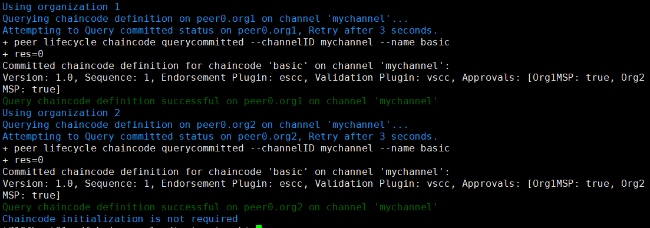

Step 1 (Within the Great Wall): Run test network,
Set the Golang Proxy,
$ go env -w GOPROXY=https://goproxy.cn

Run the test network,
$ cd $HOME/fabric-samples/test-network
$ ./network.sh up
$ ./network.sh createChannel
$ ./network.sh deployCC -ccn basic -ccp ../asset-transfer-basic/chaincode-go -ccl go
$ ./network.sh down

